New Patient Database
(*Please Complete All Questions*)

Patient’s Name: Today’s Date: ____ / _____ / _____

Part 1. DEMOGRAPHICS
Your Referring Physician: ____________________________________
Your Family Physician: ____________________________________
Your Birth Date: ______ / ______ / ______ and Your Age: ___________
Gender: Male Female AND I Am: 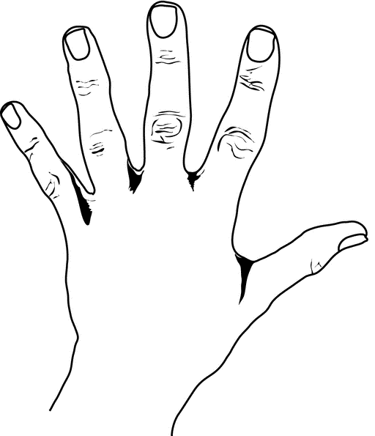 Left Handed 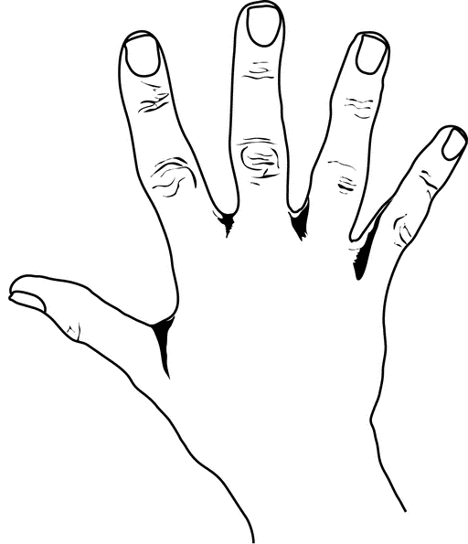Right Handed

Part 2. DESCRIPTION OF SPINE SYMPTOMS

My major concern(s) are: (Check all that apply): *If you are Experiencing Leg or Arm Please Circle Which One
Low Back Pain Neck Pain
Leg Pain (Right or Left or Both) Arm Pain (Right or Left or Both)
Leg Numbness/Tingling (Right or Left or Both) Arm Numbness / Tingling (Right or Left or Both)
Leg Weakness (Right or Left or Both) Arm Weakness (Right or Left or Both)
Upper Back Pain Scoliosis (Curved Spine or Spinal Curvature)
Kyphosis (Roundback - Upper Shoulder Area) Difficulty Walking (Prolonged Standing / Distances)

When did your spine problem First Start – How Long Ago? (Approximate Time Frame)
_________ Days _________ Months _________ Years

Please Provide Exact Date, If Known ______| ______ | ______
How was your spine problem first detected / diagnosed?
By a physician / doctor By myself
On a job screening By a family member
On a school screening Other: __________________________

Does anyone in your family have spine problems?
Yes Relationship(s): __________________________________________________
No
I don’t know

What Things AFFECT Your Symptoms (For Example: Sitting, Standing, Lifting, Bending, Twisting, Walking)
Increase My Symptoms: ___________________________________________________
Decrease My Symptoms: __________________________________________________
NOTE: Is This Due To A Motor Vehicle Accident or Personal Injury: YES or NO
* PLEASE NOTE: “OUR PRACTICE DOES ‘NOT’ DO ANY LEGAL OR PERSONAL TYPE INURY WORK”.
(This Information MUST be disclosed prior to establishing a patient-physician relationship)

Cleveland Spine Institute™ - ©New Patient Database Page 1/9

Medical & Surgical History
List ALL Your medical Health Problems (For Example: High blood pressure,
Diabetes, Heart Problems, Lungs, Kidney, Bowel, Bladder, Liver, Spleen, Blood
Conditions, Infectious diseases (e.g. hepatitis), etc.): (*You may attach written Lists)

Medical Problem How Long have you had this?
______________________________ ______________________
______________________________ ______________________
______________________________ ______________________
______________________________ ______________________
______________________________ ______________________

List ALL Surgeries that you have had: (*You may write see attached Lists)

Type of Surgery Date(s) of Surgery
______________________________ ________________________
______________________________ ________________________
______________________________ ________________________
______________________________ ________________________
______________________________ ________________________

List ALL Medications you are taking: (*You may write see attached Lists)

Name of Medications Dose How Long have you Taken
______________________ ______________ _____________________
______________________ ______________ _____________________
______________________ ______________ _____________________
______________________ ______________ _____________________

List ALL Allergies you have: Drugs / Medications / Radiographic Dyes / Foods / Seasonal

Medication Type of Reaction (e.g. rash, swelling, trouble breathing)
__________________________ ________________________________
__________________________ ________________________________
__________________________ ________________________________
*IF YOU ARE ALLERGIC to LATEX Have You Been Formally Tested ? No Yes

Smoking, e-cigarettes, Vaping or any other tobacco products - Do You DO ANY OF THESE ?
1. No I Never Smoked Packs per day # of Years

2. * Cigarettes / Cigars / Pipe: NO YES I Quit __________ ___________
3. * e-Cigarettes / Vaping: NO YES I Quit __________ ___________

* (Circle ALL That Apply) * If You Quit in What Year Did You Quit?: ____________
Do you use Other Tobacco products? Chew tobacco Nicotine patch
Do You Drink alcoholic beverages? NO YES - About How Much _____________ Have you ever taken any illicit drugs? NO YES

Cleveland Spine Institute™ - ©New Patient Database Page 2/9
Have you EVER received any of the following treatment(S) FOR YOUR ‘SPINE’
Treatment History
(Please include dates as best that you can recall them Or Please complete to the best of your ability)
If it Helped What Percent
*Check ALL When Was It Did It Help You How Long Better Where
that apply (The Month/Year) Yes No Did It Help You (0-100%)

Bed Rest _____________ ____ ____
Traction _____________ ____ ____
Back Exercises _____________ ____ ____
Back School _____________ ____ ____
Spinal Manipulation _____________ ____ ____
(Physician, Chiropractor)
Back Brace _____________ ____ ____
Electrical Stimulation _____________ ____ ____
(TENS, ESO)
Physical Therapy (PT) _____________ ____ ____
Epidural Steroids (Blocks) _____________ ____ ____
Trigger Point Injections _____________ ____ ____
Massage Therapy _____________ ____ ____
Acupuncture _____________ ____ ____
Oral Steroid Medications _____________ ____ ____
Steroid Injections _____________ ____ ____
Nerve Root Blocks _____________ ____ ____

If you had Physical Therapy (PT):

When was your PT How Long (wks / mos) Where was your PT Done
___________________ _________________ ____________________________________
___________________ _________________ ____________________________________

WERE YOU EVER IN: Name of The Program / Center Year(s)
1. Chronic Pain Program*: ____________________ _____
____________________ _____
* List the Name of “Current Pain Management Doctor”: _______________
2. Work Hardening Program: ___________________ _____

3. Vocational Rehab Program: ___________________ _____

Cleveland Spine Institute™ - ©New Patient Database Page 3/9
Diagnostic History
Have you ever had any of the following diagnostic tests for your Spine:
(*PLEASE INDICATED ALL THAT APPLY*)

TEST YES NO DATE(s) LOCATION THEY WERE DONE

X-Rays ____________ ____________________________
____________ ____________________________
____________ ____________________________

CT Scan ____________ ____________________________
____________ ____________________________

MRI * ____________ ____________________________ *Without Contrast / With Contrast / Both ____________ ____________________________

* (Please Circle ALL That Apply)

Bone Scan ____________ ____________________________
____________ ____________________________

Myelogram ____________ ____________________________
____________ ____________________________
Discogram ____________ ____________________________
____________ ____________________________
EMG ____________ ____________________________
____________ ____________________________
Bone Density ____________ ____________________________

Other Tests ____________ ____________________________

Please List Any Additional Test Here : __________________________________________

__________________________________________________________________________

__________________________________________________________________________

Cleveland Spine Institute™ - ©New Patient Database Page 4/9

Mark on the line below the point that best represents the severity of your pain ‘Most of the time’.
Pain and Symptom History
Please Draw Your Pattern of Pain

On the Diagram Below
Unbearable Pain
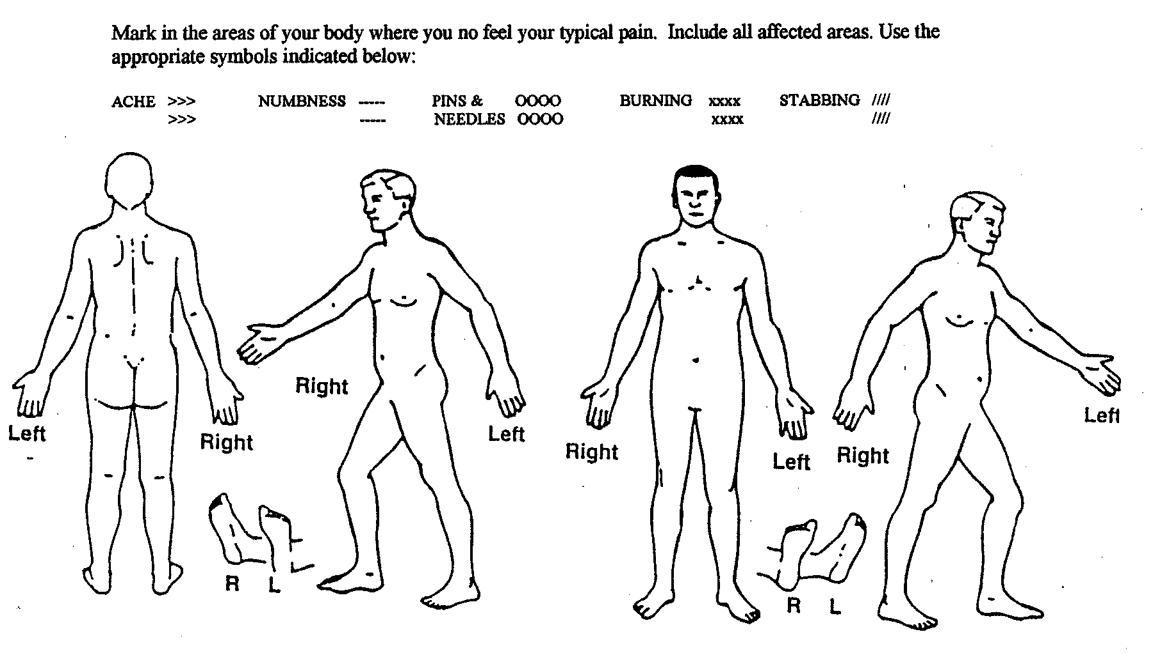
______
Mark in the areas of your body where you now feel your typical symptoms. Include all affected areas. Use the appropriate symbols below to describe your symptoms.

______
No Pain

On a scale of 0 to 10 (where 1 is very mild pain and 10 is the worst pain)
Please Rate Your Pain - (Use a Single Number (e.g. 2, 5, 9) OR A Range of Numbers (e.g. 3-4, 8-10, 1-3)
(For Example: 2/10, 8/10, 3-5/10, 7-9/10)
(*Please Check One Below – This is IMPORTANT!)
Would You Characterize Your Pain As Being?
Mild Mild to Moderate
Moderate Moderate to Severe
Severe Very Severe
______ / 10_ Pain At its Best (0 – 10)
_ _____/ 10_ Pain At its Worst (0 - 10)
___ ___/ 10_ Pain On Average (0 - 10)
AND - Please Check the One that best describes your pain pattern:
I Am Experiencing: MORE GOOD DAYS (Than Bad Days)
I Am Experiencing: MORE BAD DAYS (Than Good Days)
I Am Experiencing: EQUAL GOOD & BAD DAYS

Cleveland Spine Institute™ - ©New Patient Database Page 5/9
Does Coughing or Sneezing ‘Increase’ your ‘Pain’? YES NO

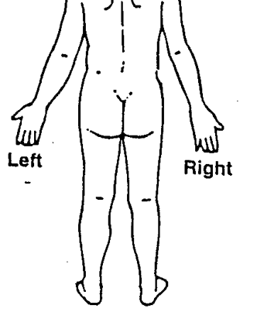 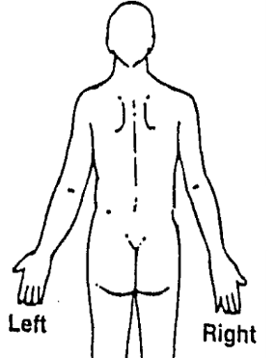
Back Pain Neck Pain
‘Circle’
Leg Pain Arm Pain
All That Apply
Both Both

If you have BOTH - Back + Leg Pain (and/or) Neck + Arm Pain

What % Percentage (of 100%) is: BACK v. LEG OR NECK v. ARM
(e.g. 30% Back Pain & 70% Leg & Buttock Pain – with the “Total Adding up to 100%”
(e.g. 60% Neck Pain & 40% Arm & Shoulder Pain – with the “Total Adding up to 100%”
Circle – Is your pain on the R or L or Both

_______ % BACK Pain vs. _______ % LEG → Right or Left or Both

_______ % NECK Pain vs. _______ % ARM → Right or Left or Both

Do You have ANY Problems With Control of you BOWEL or BLADDER ( Circle Which Apply):
1. Bowel NO YES
2. Bladder NO YES
3. Bowel & Bladder NO YES
4. Did this start: BEFORE (OR) AFTER - your Spine Problems Started?

How Long have you been experiencing Problems In: _____ Years / months
(Please Indicate)
Do You Have A Urologist: NO YES
Your Urologists Name OR Group: _____________________________________

Cleveland Spine Institute™ - ©New Patient Database Page 6/9
Are you WORKING or Have You been ABLE TO WORK despite your spine problem(s)?
Work History

_____ Yes, I Am Working - Who is your Employer: ______________________________
Please Describe your Employment: _____________________
Does your job involve heavy manual labor ? Yes No
Does your job require heavy or repetitive lifting/bending/twisting ? Yes No

_____ No, I am NOT Working
_____ I Am Retired (If retired, please skip the rest of this form)
_____ I Am on Disability - My Disability Is: A. Temporary Permanent I don’t know
B. Partial Total I don’t know

If WORKING - Are you working: Full Time or Part Time

If WORKING - Have you had to change the type of work you do or your place of
employment as a result of your spine problem(s)? Yes or No

If WORKING - How long have you worked at your present job? _____ Year(s) _____ Month(s)

If WORKING - How many hours a week do you work? _____ Hours

If WORKING - How many hours a day do you work? _____ Hours

If WORKING, Is your current work physically demanding?
_____ Extremely _____ Some what
_____ Very much _____ A little
_____ Quit a bit _____ Not at all

If You Are NOT WORKING - Approximately How Long have you been UNABLE to
work Because of your back or neck problems?
_____ Less than one month
_____ One month
_____ Between one and three months
_____ Between three and six months
_____ More than six months
What is the Date you Last Worked? _______ / _______ / ________
(Month) (Day) (Year)

Cleveland Spine Institute™ - ©New Patient Database Page 7/9
Current Pain Medications & Health Screening
I am using the following Pain Medications to treat my pain:

Tylenol products Tylenol #3 Flexaril
Aspirin products Norco Robaxin
Ultram/Tramadol Vicodin Zanaflex
Celebrex Vicodin ES Lortab
Mobic Vicodin HS Soma
Naprosyn Percocet Tramadol
Motrin Oxycontin Nucynta
Relafen MS Contin Pain Stimulator
Daypro Other Narcotics Pain Pump
LIST ANY ADDITIONAL: ______________________________________________________________

In the last month how frequently have you taken the following pain medications?

 | 3 – 4  Times a day | 1 – 2  Times a  day | 1 – 2  Times a week | 3 – 5  Times a month | 1 - 2  Times a month | Not At  All
Narcotics
(T3, Codeine, Darvocet,
Vicodin, Percocet, etc.)
Non-Narcotics
(Aspirin, Advil, Motrin,
Relafen, Vioox, etc.)

Health Screening: Do you have or have you been treated for any of the Following?

CONDITIONS | YES | NO | NOT SURE

High Blood Pressure / Hypertension
Heart Problems (Angina, Heart Attack, Blocked Arteries, ect.)

Breathing / Lung Problems
(Asthma, Emphysema, ect)

Kidney / Bladder / Urinary

Stomach / Intestine problems
(Ulcers, Polyps, Cancer, Reflux, ect)

Ear / Eye problems

Nose / Throat problems

Skin conditions

Headaches

Stroke

Blood Clots / Phlebitis

Bleeding / Blood Disorders

Cancer

Diabetes

Arthritis
Osteoporosis

Cleveland Spine Institute™ - ©New Patient Database Page 8/9

PLEASE feel free to ADD any additional information BELOW that you feel or believe may be pertinent or relevant to your spine care and treatment (if it was not covered above). Also, please be prepared to provide copies of all previous diagnostic studies
(X-Ray, MRI, CT Scan, ect), along with their associated reports. Any relevant studies and associated reports, tests and test results as well as all operative reports will be required to provide complete care. If these are not available for us today, it will be your responsibility to obtain and provide copies of all relevant information.

___________________________________________________________________________________________
___________________________________________________________________________________________
___________________________________________________________________________________________
___________________________________________________________________________________________
___________________________________________________________________________________________
___________________________________________________________________________________________
___________________________________________________________________________________________
___________________________________________________________________________________________
___________________________________________________________________________________________
___________________________________________________________________________________________
___________________________________________________________________________________________
___________________________________________________________________________________________
___________________________________________________________________________________________
___________________________________________________________________________________________

Cleveland Spine Institute™ - ©New Patient Database Page 9/9

